TruSlumber encourages a good night’s rest that will allow you to begin the new day with renewed focus and energy. With no ingredients that may cause addiction or harmful side effects, you can rest easy with TruSlumber
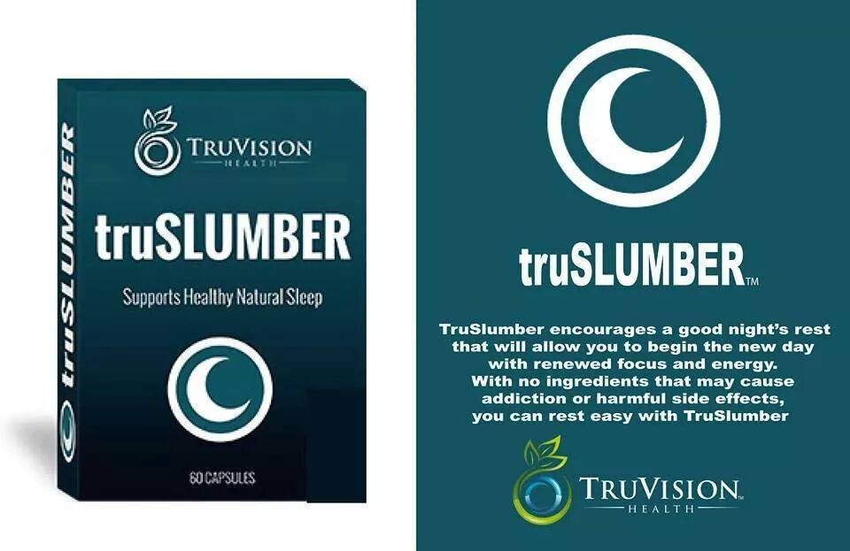
A Good Nights Sleep Non- Addictive No Harmful Side Effects
Sleeping disorders affect over 60% of people. These disorders range from not getting a full night’s sleep 1 or 2 nights a week to sleep apnea. This is no surprise when one considers the stress levels we encounter in our modern-day lifestyles. We are constantly multi-tasking and trying to accomplish more and more. It is no wonder that we can’t get our minds to slow down long enough for us to get 7-8 hours of solid sleep each night. TruSlumber was developed to answer the need for better sleep.
The secret to the effectiveness of TruSlumber’s ingredients are the sources for the extracts used in the formula. For example, melatonin is commonly used in natural sleep products. However, all melatonin is not equal. We scrutinized the sources for all of the ingredients in TruSlumber and analyzed their chemical profiles. Simply put, our ingredients perform better than the sources used by other formulators.
Ingredients
Cyracos has been clinically proven to help reduce stress and encourage relaxation. To guarantee a constant quality, Cyracos® contains the following molecules: Hydroxycinnamic acids, - A particular hydroxycinnamic acid – rosmarinic acid – known in the scientific world for its health benefits.

Chamomile Besides its sleep and relaxation benefits Chamomile is helpful for a variety of stomach problems. It soothes stomach aches, eases the symptoms of irritable bowel syndrome, promotes elimination, and assists in overall digestion. It can also help calm menstral cramps as well as boosts the immune system. Chamomile tea is being studied for its beneficial effects in the management of diabetes. In one study daily consumption of chamomile tea was found to prevent the progression of diabetic complications and hyperglycemia.

Passiflora incarnata, more commonly called passion flower, is an herbal remedy with calming effects. Passion flower may increase the amount of gamma-aminobutyric acid (GABA) in the brain, as explained by the University of Maryland Medical Center (UMMC), and GABA decreases the activity of certain brain cells.

Gamma-amino butyric acid or GABA is a neurotransmitter that acts to reduce communication between nerve cells in the brain, producing a calming effect. Gaba makes it easier to fall asleep by lowering the activity of neurons in the brain. Gaba might also increase the amount of human growth hormone in the body, which might improve sleep cycles and decrease disruptions in sleep.

Melatonin- Perhaps one of the best known natural sleep remedies, New research indicates that melatonin does much more than help some people sleep better. Exciting studies show that melatonin’s multifaceted effects may improve treatment outcomes in cancer patients and extend their lives. Additional applications of melatonin include guarding the nervous system against degenerative diseases—such as Alzheimer’s disease and stroke—and preventing debilitating migraines.

