truMEND is a remarkable first aid balm that contains a powerful combination of natural ingredients for cuts, scrapes, abrasions, bug bites and other skin irritations.

truMend

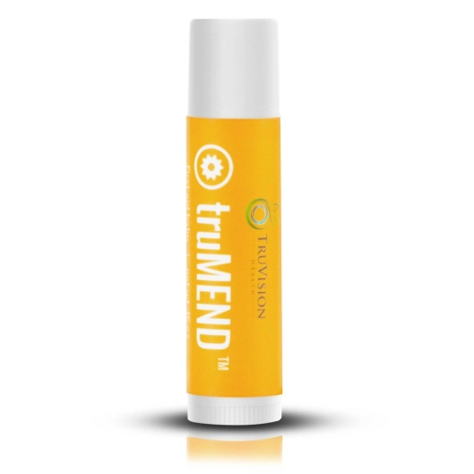

100% Natural Powerful Healing Properties Anti-Aging Benefits Unfriendly to Bacteria
In addition to anti-inflammatory and antiseptic properties, the ingredients in truMEND also provide powerful antioxidants known to help slow aging of the skin. Use it as an eye cream, on wrinkles, and as a moisturizer! This versatile balm can also be used on skin breakouts, canker sores (yes, it is safe to put in the mouth), bee stings, sunburns, blisters, scars, eczema, diaper rash, and chapped lips. Other uses include hemorrhoid relief, athlete’s foot, and chicken pox — and even reduces foot and body odor! truMEND promotes accelerated healing & healthy skin growth for the entire family!* Made with 100% natural ingredients.

Individual Ingredients:
BEESWAX Beeswax contains “wax esters” that also exist in human skin. As a natural hydrating ingredient that increases skin’s essential moisture, beeswax helps retain natural skin moisture and relieve itch from sensitive skin. Beeswax forms a protective barrier on the surface of the skin. This barrier provides a film of protection against irritants while still allowing the skin to breathe. Beeswax is beneficial for treating minor skin irritations. It contains vitamin A, which may be beneficial in softening and rehydrating dry skin and in cell reconstruction.

OLEA EUROPAEA (EXTRA VIRGIN OLIVE) OIL Cinnulin is the only cinnamon extract that exclusively contains the specific polyphenols responsible for the many health benefits of cinnamon. These benefits include blood sugar management, subtle weight loss benefits, deceleration of the aging process, enhanced lean body mass, lowering of high blood pressure and absorption and utilization of antioxidants.

HELIANTHUS ANNUUS (SUNFLOWER) SEED OIL Sunflower Seed Oil works as a protective and moisturizing solution for skin. Any skin type can easily absorb sunflower oil, making it a good choice for those suffering with acne. Sunflower oil is rich in vitamins A, C, D, and E, which supports overall skin health.

CALOPHYLLUM INOPHYLLUM (TAMANU) SEED OIL Tamanu Oil is a remarkable topical agent, with general skin soothing actions. Historically, Tamanu Oil has been considered a cure-all in Africa, Asia, Polynesia, and the Pacific Rim. The Chinese are also known to use this oil to support the body as it works to combat various skin problems. Tamanu Oil is unfriendly to bacteria and has antioxidant, anti aging, and anti wrinkle properties. It is reputed to be helpful for virtually any skin irritation, scar, wound, infection, burn, sunburn or abrasion. Tamanu oil provides an added boost to the healing process the body naturally supplies.

CALENDULA OFFICINALIS FLOWER EXTRACT Calendula extract assists the body’s natural skin healing processes. It has been shown that Calendula stimulates the regeneration of wound tissue since it intensifies the metabolism of glycoproteins, nucleoproteins and collagen during the healing process.

BUTYROSPERMUM PARKII (SHEA BUTTER) FRUIT Shea Butter has been used to help burns, sores, scars, dermatitis, psoriasis, dandruff, and stretch marks. It may also help diminish the appearance of wrinkles by moisturizing the skin, promoting cell renewal, and increasing circulation. Shea butter is a particularly effective moisturizer because it contains so many fatty acids, which are needed to retain skin moisture and elasticity. Shea butter protects the skin from both environmental and free-radical damage. It contains vitamins A and E.

HIPPOPHAE RHAMNOIDES (SEA BUCKTHORN) SEED OIL Sea Buckthorn Oil is a natural source of vitamin A, vitamin E and several other tocopherols. It is reputed to be one of the best sources of natural antioxidants due to the high content of vitamin C. Sea buckthorn oil effectively combats dryness, the appearance of wrinkles, and other symptoms of dry, aged skin. It is also used to promote healing of burns, eczema, and small cuts or wounds.

ROSA CANINA (ROSEHIP) SEED OIL Rosehip Seed Oil is high in essential unsaturated fatty acids, namely oleic, linoleic, and linolenic. Rosehip seed oil is also high in vitamin A and retinoic acid, a natural constituent similar to Retin-A, but without the negative side effects. Retinoic acid markedly improves the complexion by visibly reducing the appearance of fine wrinkles, and improving pigmentation and fine texture of the skin. Lightly massaged into the skin, this oil acts on the cell membranes, supports their immune reaction, and initiates their regeneration. Studies have shown rosehip seed oil to have a positive effect on scars and stretch marks. Scars caused by injury or surgery are effectively treated to reduce the red coloration and the appearance of lumps that often occur. Excellent results have been obtained through its anti-inflammatory properties in improving burning skin and dermatitis caused by radiotherapy.

MELALEUCA ALTERNIFOLIA (TEA TREE) LEAF OIL Tea tree essential oil (also known as Melaleuca) is best known for its antimicrobial activities. Tea tree essential oil contains Terpinen-4-ol which is reputed to be responsible for fighting all three categories of infectious organisms (bacteria, fungi, and viruses). Tea tree essential oil has been used to fight acne, dandruff, athlete’s foot, lice, eczema and psoriasis. In the treatment of moderate common acne, topical application of 5% tea tree oil has shown an effect comparable to 5% benzoyl peroxide. Tea Tree essential oil has also been used to help with burns, cold sores, gum disease, rashes, sore throat, asthma, bronchitis, warts, insect bites, flu, and wounds.

ROSMARINUS OFFICINALIS (ROSEMARY) LEAF EXTRACT Rosemary extract has strong antioxidant properties which help to slow oxidation and has anti-aging properties as they reduce the damage caused by free radicals. Rosemary extract also has a great ability to increase circulation in the skin for overall improved skin health.

LAVANDULA ANGUSTIFOLIA (LAVENDER) OIL Lavender essential oil contains more than 150 compounds and has very potent antiseptic properties. It can help treat a number of skin problems such as burns, dry skin, eczema, and itchy skin. It is most commonly associated with burns and healing of the skin. Lavender has been used historically to help with many skin-related conditions including acne, allergies, burns (cell renewal), diaper rash, herpes, minimizing scarring, stretch marks, thrush, bruises, cold sores, hiv es, insect bites, beestings, infections, and sunburns.

CITRUS MEDICA LIMONUM (LEMON) PEEL OIL Lemon essential oil has both antioxidant and antiseptic properties. Lemon consists of 68% d-limonene, a powerful antioxidant beneficial for the skin. It has cleansing and purifying properties. It supports healthy skin and circulatory system and is a powerful detoxifier. Lemon essential oil has the ability to activate white blood cells that defend the body against infection. Lemon essential oil is good for balancing oily skin, and can also smooth and rejuvenate dry or cracked skin.
STYRAX BENZOIN RESIN EXTRACT Benzoin is reputed to have antiseptic, anti-depressant, anti-inflammatory, deodorant, and diuretic properties. Benzoin is thought to be helpful with skin conditions such as acne, eczema, and psoriasis. It improves skin’s elasticity and helps cracked skin. It aids the healing of sores and wounds while reducing redness, irritation, and itching.

