Engineered with healthy, natural plant extracts, TruFix benefits every system in the body. It benefits blood sugar, lower cholesterol, healthy liver function, and more! Improving your general health has never been easier!
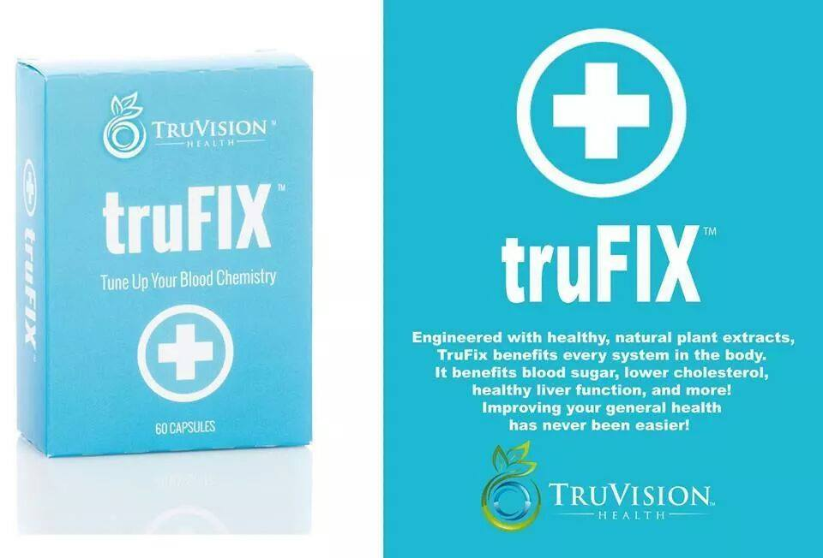

Natural Plant Extracts Lower Blood Sugar & Cholesterol Healthy Liver Function

Blood Chemistry – A Vital Key To Longevity And Health
For many years blood tests have been a primary tool for identifying disease and other unhealthy imbalances in the body. Our blood chemistry contains components known as markers. These markers are used to evaluate a person’s health. For example, if an individual’s cholesterol is too high, it is an indicator of poor cardiovascular health. If a person’s uric acid is too high, this can also be an indicator of heart disease and overall poor health.
These are what we could call the “negative” aspects of blood chemistry. Now let’s look at the positive side. We invite you to ponder this thought; the better a person’s blood chemistry, the higher the likelihood they will have maximum longevity and live that extended lifespan in optimal health. What if there was a supplement that could help improve blood chemistry? That is the founding principle behind the engineering of TruFix. TruFix is a powerful combination of natural ingredients that have been clinically proven to improve key components of blood chemistry. It is important to note that almost all ingredients when used in excess can have a negative impact on one’s health. Our formulations use all ingredients in moderation and well below any toxic levels.
Ingredients
Alpha Lipoic Acid (ALA) is a beneficial fatty acid that is produced in every cell of the body. One of it’s principle functions is to help convert glucose (blood sugar) into energy. It is also a powerful antioxidant that neutralizes potentially harmful molecules called free radicals. Free radicals have been linked to cancer, accelerated aging and many other debilitating and potentially terminal conditions. Studies have shown that ALA can also help with high blood pressure, diabetes, impaired brain function, degenerative diseases, some forms of neuropathy, high cholesterol, cardiovascular disease, some forms of cancer, arthritis and other inflammatory conditions and many degenerative diseases.
Cinnulin is the only cinnamon extract that exclusively contains the specific polyphenols responsible for the many health benefits of cinnamon. These benefits include blood sugar management, subtle weight loss benefits, deceleration of the aging process, enhanced lean body mass, lowering of high blood pressure and absorption and utilization of antioxidants.
Chlorogenic Acid essentially retrains your body to more effectively seek out and utilize body white adipose tissue (the undesirable type of fat) stores for energy. It helps regulate blood sugar, lowers high blood pressure, decelerates the aging process, improves brain function and mental clarity. It also contributes to overall healthier blood chemistry. When blood chemistry is improved, virtually every major system and organ in the body benefits
Chromium is known to help regulate glucose and assist the metabolism of glucose on a cellular level the supplies the body with energy. It is also reported to slow the loss of calcium, help prevent glaucoma and regulate cholesterol. Low chromium levels may contribute to coronary artery disease. Chromium also assists the body in building lean muscle tissue while assisting the body in white adipose tissue.
Copper helps the body produce red blood cells thus avoiding anemic conditions. When taken with zinc and magnesium it can also help prevent calcium loss, especially in women during menopause. It may also assist in wound healing and alleviation of arthritic symptoms.
Magnesium can help prevent calcium loss when taken with Copper and Zinc. It is also an effective preventative supplement. Magnesium deficiencies may be linked to kidney disease, Crohn’s disease, other digestive ailments.
Raspberry ketones are an enzyme extracted from raspberries. This enzyme increases the production of the protein hormone adinopectin. This hormone controls metabolic deviations that could lead to weight gain. When used alone as a weight loss supplement, it has not been shown to be very effective. It is usually combined with stimulants. It is included in TruFix as a complimentary ingredient for metabolism regulation and also for it’s significant antioxidant benefit. It may also help prevent the build up of plaque in the arterial walls and may reduce the risk of liver cancer.
Selenium is a powerful antioxidant. It is often used in formulas to fight cancer, heart disease and aging. It has also been used to fight viral infections.
Vanadium helps improve the efficacy of the body’s naturally produced insulin. Insulin helps regulate glucose (blood sugar) and neutralizes blood sugar spikes
Zinc is an essential trace element. It boosts the immune system; helps prevent diseases of the eyes and can help tinnitus (ringing in the ears). It also may help individuals with ADHD, osteoporosis and prostate issues. Some athletes use zinc to enhance athletic performance and strength.

