truDEFENSE is an essential oil blend formulated for immune system support

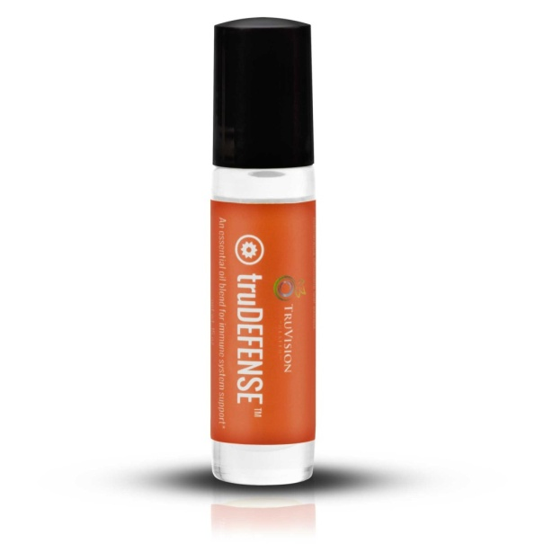
truDEFENSE is an essential oil blend formulated for immune system support. This blend of five immunity-boosting essential oils offers you a natural and safe alternative to synthetic options. When carefully blended together, the essential oils of clove, cinnamon, lemon, eucalyptus, and rosemary synergistically come together making the oils more powerful together than they are on their own. When applied topically, these oils are absorbed by the skin and quickly enter the bloodstream where they circulate throughout the body to stimulate the immune system.* Made with the highest quality essential oils available.
Directions for use: As a preventative measure, massage truDEFENSE into the bottoms of the feet daily for the quickest absorption. For best results, cover the feet with socks after application.
Safety Information: If pregnant or lactating, consult a practitioner before use. Keep out of reach of children.
The essential oils in truDEFENSE are pre-diluted in sunflower oil for safety and ease of use. Although this product is intended to be used on the bottoms of the feet, it may also be use it on wrists, behind ears, down the spine and on the neck and chest, only after checking for skin sensitivity. The essential oils in this blend are very hot oils. If the blend is too hot on areas other than the bottoms of the feet, apply a carrier oil such as olive oil (never water) to dilute the oils and soothe any irritation.
Individual Ingredients
HELIANTHUS ANNUUS (SUNFLOWER) SEED OIL Sunflower seed oil has been formulated into this blend for two purposes. 1) Sunflower oil absorbs quickly into the skin and does not evaporate like essential oils do – aiding in the absorption of the blend into the bloodstream. 2) Clove and cinnamon oils are very “hot” oils that can irritate the skin if not diluted. Sunflower oil is used as a light carrier oil to dilute these hot oils down so they may be used safely on the skin. Those with sensitive skin may dilute this blend further by applying a layer of any carrier oil to the surface of the skin before and after the application of truDEFENSE (if used on areas other than the bottoms of the feet).
EUGENIA CARYOPHYLLUS (CLOVE BUD) FLOWER OIL Cloves were among the most precious of items of Europe in the 16th and 17th centuries. Clove bud essential oil has historically been used for digestive problems, exhaustion, infection, burns and cuts, arthritis, asthma, colds, coughs, and sore throats. It is also used as an insect repellant, especially for mosquitoes.

CITRUS MEDICA LIMONUM (LEMON) PEEL OIL Lemon essential oil is obtained by the cold expression of the outer part of the fresh lemon peel. It can take up to 3,000 lemons to produce 35 ounces of lemon essential oil. Research has shown lemon essential oil to dispel mental fatigue and enhance the ability to concentrate. Properties of Lemon essential oil include: Antibacterial, antifungal, anti-inflammatory, antimicrobial, antirheumatic, antiseptic, antispasmodic, astringent, carminative, digestive, and diuretic. It has been used in the treatment of colds and flu as well as many other health-related issues.

EUCALYPTUS GLOBULUS LEAF OIL Eucalyptus Globulus contains 60-75% “1,8-Cineol” which is considered an anti-infective agent. Eucalyptus globulus oil is widely known for combating congestion and respiratory problems. Historical records indicate that this essential oil was also used to treat sore muscles and joints. In addition eucalyptus has been used to improve acne, hay fever, inflammation in nasal passages, flu, asthma, migraines, respiration, diabetes, allergies, bronchitis, flu, and rheumatism.

ROSMARINUS OFFICINALIS (ROSEMARY) LEAF OIL Rosemary essential oil is useful for respiratory issues and makes a good expectorant and decongestant. It also has anti-bacterial, antiseptic, and pain-relieving properties.

CINNAMOMUM ZEYLANICUM (CINNAMON) BARK ESSENTIAL OIL Cinnamon bark essential oil is highly respected for its antiseptic properties and pleasant scent. It is steam distilled from the cinnamon bark. This oil may be helpful for colds, flu, coughs, infections, and exhaustion.

