Whether you’re looking to shed those stubborn pounds, lose the body fat, or just feel more energized throughout the day without the jitters, TruWeight & Energy has you covered. With no special diet required, this low maintenance, multi purpose supplement may be just what you’ve been waiting for!
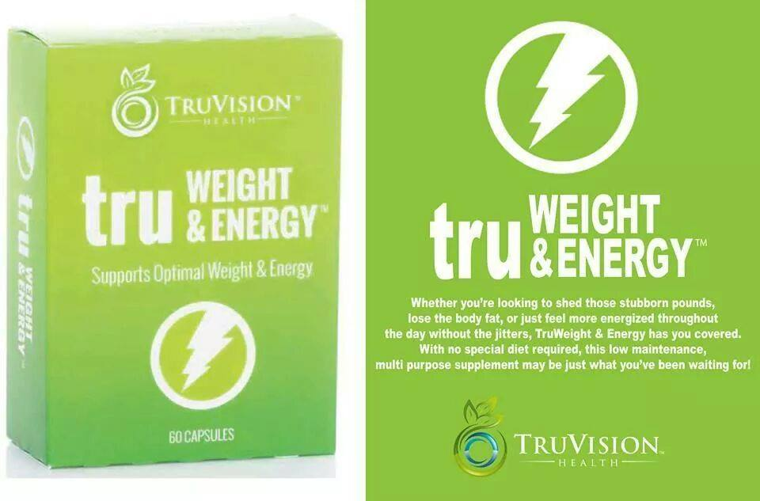

Lose Body Fat Feel More Energized No Special Diet Required

Excess weight has reached epidemic proportions in the United States. Over 50% of Americans carry excess weight. Over 30% of American’s are clinically obese. What caused this? Simply put, lifestyle. We overeat, we eat “fast sugar” foods, and we don’t exercise enough. The tragedy is, this is affecting children more than ever before. More and more children begin carrying excess weight as early as elementary school. By the time they are teens, many of them are clinically obese. Many times these children have the odds against them. Over 50 years ago a trend started taking hold of eating larger portions of unhealthy “fast sugar” foods combined with less exercise, especially among children and teens. Now we are in the 3rd and 4th generation of overweight parents passing on both their digressive genetics and lifestyle habits that encourage obesity in their children. Excess weight is a major cause of diabetes, cardiovascular disease and many other debilitative and life-shortening diseases and conditions. 1 out of every 3 cancer deaths is linked to excess body weight.
We are dedicated to stopping the trend of carrying excess weight. Our objective is to help people lose their excess weight in a manner that is both healthy and realistic. Modifying diet, sleep habits and exercise habits is the best way to shed excess pounds. The reality is, most people are unwilling to stick with these kinds of changes. Even if they start out with a program that modifies these behaviors, sooner or later they usually “fall off the wagon”. And when they do, they not only gain back the weight they lost but usually put on additional weight. Our method involves optimizing the body’s metabolic processes in a way so simple that there is “no wagon to fall off of”. So undemanding, anyone can do it. We accomplish this through our product TruWeight&Energy. Taking two capsules twice a day is the simple regimen.

Formula Overview
Our objective in engineering this formula was to provide a healthy means for individuals to lose excess weight and experience increased energy. There are some stimulants in this formula because they are necessary to effect the systemic and metabolic changes required to lose excess adipose tissue (fat). However, we have been very careful not to use substances or dosages that could result in addiction or compromise the cardiovascular system. This formula has been engineered to be beneficial in enhancing people’s health.
Ingredients
AMP (4-Amino-2-Methylpentane Citrate) is a substance produced in Pouchung Tea. It acts as a metabolism “booster” and assists the body in metabolizing fatty tissue. When combined with other ingredients such a nominal amounts of caffeine, bitter orange and Phenylethylamine (PEA) it enhances the body’s ability to shed adipose tissue in a healthy manner without the side effects of jitters or cardiovascular complications. As the body metabolizes excess fat stores a subtle increase in energy is usually experienced.
Green tea enriched in Epigallocatechin gallate (EGCG) shows significant results in helping individuals maintain their weight. Green tea has long shown promise in helping individuals maintain a healthy weight, after significant green tea research it is now believed that the EGCG compound is what contributed to the reduction in weight. There are three hypothesis on how Green Tea EGCG helps in promoting a healthy weight: 1) Increase blood flow – By increasing the blood flow throughout the body, there is increased oxygenation to muscles and thereby increasing caloric demands; 2) When combined with a nominal amount of caffeine allow for increased fat oxidation (Dulloo et al, 1999); and 3) modulating insulin effect – Regulating the signaling of insulin in response to carbohydrate consumption allows one to not be as susceptible to blood sugar spiking (Li et al, 2006). Green Tea is also a rich source of anti-oxidants.
Dendrobium is one of fifty of fundamental herbs in traditional medicine. It is found in certain species of the Orchid family. The complexity of the plant is largely attributed to its unique profile of alkaloids, such as: Dendrine, Nobiline, Nobilonine, etc (Dr. Duke Phytochemical Database). Extracts enriched in dendrobium alkaloids show many beneficial effects, including: increased focus, enhanced confidence, and increased energy. Unlike other stimulants these effects are not typically seen with an increase in blood pressure. Because of Dendrobium’s unique properties it is considered to be highly effective when coupled with synephrine (Bitter Orange) and nominal amounts of caffeine in helping individuals obtain their weight loss goals.
Bitter Orange- The combination of Bitter Orange peel and caffeine is a safe alternative to thermogenic products. The active ingredient in Bitter Orange is Synephrine, which is a primary amine similar to ephedrine and phenylethylamine (PEA) (Figure 1). However, in contrast, synephrine shows no negative side effects that eventually limited the sale of ephedra(Stohs et al., 2012). Bitter orange works by increasing the amount of glucose consumption by binding to adrenoreceptors, but at a much lower and healthier K_{d} than ephedrine (Stohs et al., 2011; Hong et al., 2012; Vinson et al., 2012).
Synephine Ephedrine
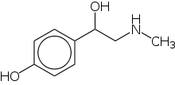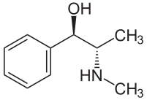

Phenylethylamine (PEA )-One of the active stimulants found in chocolate is Phenylethylamine (PEA). PEA, is an alkaloid commonly found in chocolate that encourages increased release of dopamine, which when consumed in chocolate creates the “Chocolate High”. The euphoric feeling associated with PEA usually lasts between 5-20minutes, but allows for enhanced motivation from the release of dopamine. The increase in mood can often be found to encourage exercise and other activities associated with increased caloric expenditure. Because of the ability to enhance mood and promote exercise, PEA is found in a variety of top selling weight management products.
Caffeine -This formula does contain a small amount of Caffeine. The use of caffeine in moderation and in the right application (i.e. the caffeine contained in headache tablets), has a positive effect on one’s body. This formula does not contain a sufficient amount of caffeine to cause addiction or withdrawal symptoms. Just enough is used to act as a catalyst in activating other key ingredients in the formula.
Piperine, the active ingredient in black pepper, has been patent proven to enhance the absorption of molecules into the body(Majeed et al., 1996). This is critical since many compounds are prematurely metabolized into inactive forms through oral ingestion. Black pepper extract thereby stimulates the active absorption of these compounds into the body allowing for enhanced and sustained effects of the active ingredients. Furthermore, piperine, has been shown to act as a fat burner similar to capsaicin by increasing basal metabolic rates(Diepvens et al., 2007; Hursel and Westerterp-Plantenga, 2010).
B-6 helps metabolize fat and is a natural diuretic which helps the body avoid water retention. B-6 also helps maintain blood sugar in a normal range. It can also have a healthful stimulating effect on the thyroid. It is a water soluable vitamin that functions as a co-enzyme, essential in the breakdown and utilization of carbohydrates and proteins. It also aids in the repair of tissue and cells.
B-12 can normalize appetite and give greater levels of energy thus fighting fatigue. It is also known to lessen muscle pain and promote better sleep. It can enhance mood, and combat mild levels of depression. It also contributes to clarity of thought and focus. It contributes to overall motivation to maintain an active life style.
Chromium- The body uses chromium in the digestive process. It helps maintain nominal blood sugar levels. It is also reported to aid in building muscle tissue and burning fat. It may also slow the loss of calcium thus helping to prevent osteoporosis. If a person is not getting enough chromium it may affect eye health and increase the risk of developing high cholesterol levels thus increasing the risk of developing Coronary Artery Disease (CAD). Supplementing with chromium may lower triglycerides and total cholesterol levels in people with high blood sugar and diabetics.

