An active lifestyle requires an active drink that not only hydrates your body, but also promotes healthy heart living. With no sugar and just a few calories, you’ll always want to carry with you a Heart & Hydration stick pack to replenish and support your Tru style of living!
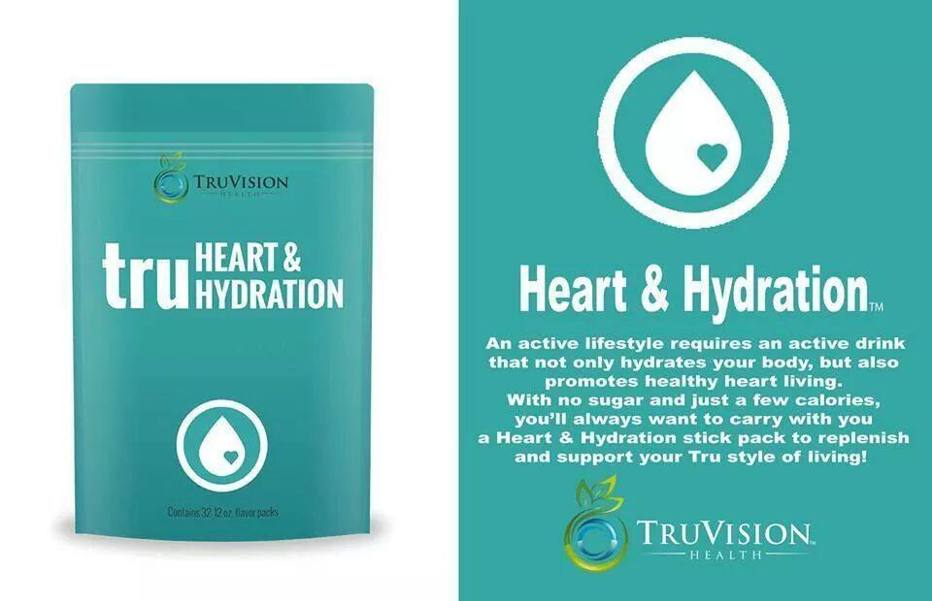

Hydrates your Body Promotes a Healthy Heart No Sugar, Low Calories
TruVision Health’s Heart & Hydration is an excellent alternative beverage to today’s sugared, carbonated and stimulate-laden beverages. Proper hydration combined with electrolyte replenishment is also of paramount importance. Our Heart & Hydration product services two vitally important needs of the body:
- Cardiovascular Function – With today’s stress levels, sleep patterns and unhealthy eating behaviors, more and more people are succumbing to cardiovascular disease. Our drink supplies ingredients vital to good heart health.
- Proper Hydration And Replenishment Of Electrolytes On A Cellular Level – Dehydration is a destroyer of proper cell function and affects virtually every major organ and system. Electrolytes are charged particles found in body fluids that help transmit electrical impulses for functioning of the heart, muscles and nerves. Our drink rehydrates and replenishes electrolytes in a healthy way without unhealthy ingredients such as sugar, caffeine or carbonation.

Ingredients
CoQ10 is an enzyme found in all cells throughout the body and is essential for the conversion of glucose into cellular energy. However, several reports show that as one ages their levels of CoQ10 decrease and low levels are observed with individuals with many cardiovascular ailments. In this formula, CoQ10 is added to promote cardiovascular health.
D-Ribose is the basic building block of our DNA molecules. Evidence suggests that a diet rich in D-Ribose promotes better muscle endurance. Additionally, several scientific reports suggest that D-Ribose may improve blood flow to the heart and allow for increased circulation throughout the body.
Calcium is one of the most needed elements in our bodies, including our heart muscle function and rhythm. However, only 20-30% of the calcium we consume through our food is absorbed into our bodies. Di-Calcium Malate is a combination of Malic Acid and Calcium, two natural ingredients, which when conjugated together allows for greater absorption of Calcium into our bodies.
Di Potassium Phosphate& Potassium Citrate- Besides serving as excellent sources for electrolyte replacement, these ingredients help deter the build up of lactic acid in the body. Lactic acid has the potential to decrease strength and endurance. It assists in the body’s energy metabolism. A sustained sufficient level of electrolytes in the body also helps improve synaptice functions of the brain.
Elderberries are used for its antioxidant activity, to lower cholesterol, to improve vision, to boost the immune system, to improve heart health and for coughs, colds, flu, bacterial and viral infections and tonsillitis. Bioflavonoids and other proteins in the juice destroy the ability of cold and flu viruses to infect a cell. Elderberries contain organic pigments, tannin, amino acids, carotenoids, flavonoids, rutin, viburnic acid, vitamin A and B and a large amount of vitamin C.
Ginseng- Largely known for its cognitive properties, ginseng has also been reported to aid in several aspects of heart health. Ginseng is thought to attribute to the induction of human cholesterol metabolizing enzymes making one able to properly utilize ones cholesterol. Additionally, the relaxation properties of ginseng have been reported with several smooth muscle tissues, including the heart.

