Health-conscious deodorant for a healthy and active lifestyle with 100% natural ingredients that simply WORK!
simplyFRESH

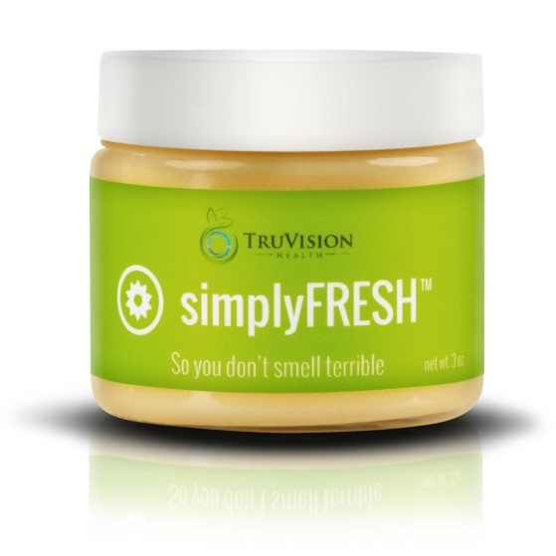
This health-conscious deodorant was formulated to complement a healthy and active lifestyle with 100% natural ingredients that simply WORK! Scented with an enticing blend of bergamot and lime using only the purest essential oils available — you’ll stay smelling fresh all day — without any harmful chemicals! This product may also stimulate lymphatic flow for toxin release and improved immune function!
The application method allows you to apply with fingertips after putting on clothing, eliminating the issue of getting white residue on your clothing. A pea-sized amount is all that is needed for both underarms. To apply, place a small amount into clean underarms. Allow the body to warm deodorant for several seconds, then gently pat into skin.

Individual Ingredients:
MARANTA ARUNDINACEA (ARROWROOT) ROOT POWDER Arrowroot powder is an edible powder that comes from the root of a perennial plant. Arrowroot is effective in safely absorbing wetness and odor.

SODIUM BICARBONATE Sodium bicarbonate, also known as “Baking Soda”, is a wonderful odor absorber and neutralizer. It also has cleansing and exfoliating properties.

COCOS NUCIFERA (VIRGIN COCONUT) OIL Virgin Coconut Oil is unfriendly to odor-causing bacteria and creates a breathable barrier on the skin. It has a very slight coconut scent and is solid at room temperature and liquid in warm temperatures.

BUTYROSPERMUM PARKII (SHEA) FRUIT BUTTER Shea butter is rich in cinnamic acid. It has moisturizing properties that make it a perfect ingredient in massage butters, body butters, lip balms and other products that moisturize. It is also used as a treatment for minor skin wounds and irritations.

THEOBROMA CACAO (COCOA) SEED BUTTER Cocoa Butter has a soft, sweet cocoa aroma and is one of the most stable fats known. It is the natural fat extracted from cocoa beans during the process of separating the powder and liquor from the bean. It has been used to heal and moisturize skin that has been exposed to the elements. It also helps reduce the formation of stretch marks during pregnancy by keeping the skin supple. It also contains natural antioxidants.
CITRUS AURANTIUM BERGAMIA (BERGAMOT) FRUIT OIL The benefits of bergamot are many and include combating stress. Its sweet and fruity aroma is uplifting and relaxing. Bergamot also has antibacterial properties which are effective against odor-causing bacteria.

CITRUS AURANTIFOLIA (LIME) OIL Lime essential oil has a fresh, lively aroma that is stimulating and refreshing. Lime essential oil is antibacterial and has deodorizing and lymphatic system cleansing properties.

