Simply Clean
An all-purpose cleaner that is 100% bio degradable and non-toxic. Safe and easy to use, this sanitizing agent can be used on any kind of wall, counter top, appliance, cabinet, carpet, wood, or upholstery.
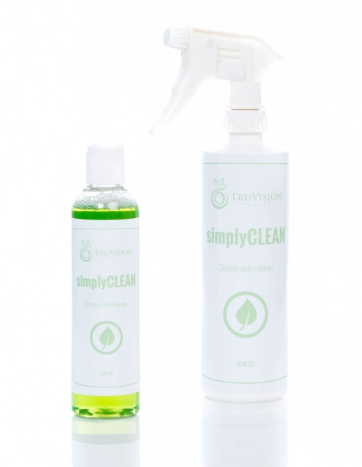

100% Bio Degradable Safe and Easy to Use All-Purpose
SimplyClean is truly a unique general surface cleaner utilizing Colloidal Action. Until recent years it has only been available to professionals but has been proven in the commercial cleaning industry for many years. It out-performs retail store products in safety, cleaning power and cost effectiveness. It is highly concentrated. One 8oz bottle of SimplyClean concentrate will fill our 16oz spray bottle 8 times! Also, when you’re working with a concentrate, you decide the strength of the solution you’re working with. If you have an extra tough cleaning job, simply use more concentrate and less water in your spray bottle.
Non-Toxic: SimplyClean is completely biodegradable, and non-toxic making it safe to people, plants, and animals. Say good-bye to harmful vapors, and the worry of accidentally leaving your cleaner where small children can reach it. It is organically formulated and free of petroleum distillates, solvents, phosphates, and other polluting agents. It does not irritate normal skin and is safe to use on any surface not harmed by water. SimplyClean passed one of the toughest toxicity tests known as the Biological Oxygen Demand test with flying colors. It absolutely will not harm people, plants animals or fish.
What is Colloidal Action? When SimplyClean is mixed in various concentrations it is effective in cleaning virtually any surface or material. Water activates the colloids which instantly begin their constant swirling, magnetic-like, super penetrating action. The colloid structure breaks, absorbs and holds particles of dirt, grime, grease and oils in suspension. These dirt and grime particles are no longer able to stick together or adhere to a surface and can be simply wiped or flushed away.
Bacteriostatic and Sanitizing Qualities: SimplyClean has been approved by the USDA for use on food preparation surfaces. SimplyClean sanitizes surfaces in two ways. First, its Bacteriostatic qualities kill common bacteria such as Ecoli and Samonilla. Second, it’s colloidal action wisks away bacteria as well as dirt and soil.

Where to Use
- Counter tops
- Walls (Papered and Painted)
- Cabinets
- Carpets
- Upholstery
- Tile, Linoleum, Wood Floors
- Stove Tops and Hoods
- Ovens
- Fiberglass and Plastic Surfaces
- Leather & Vinyl
- Wood & Wood Veneer
- Fabrics
- Vehicles (Outside and Interior)
- Any Surface Not Harmed By A Damp Cloth

Use to Clean
- Dirt
- Food Spills On Carpets, Upholstery And Fabrics
- Grease Build Up Such As Is Found On And Around Stoves
- Grime

409 Multi-Purpose Cleaner
15 ¢ ounce

Simply Clean Multi-Purpose Cleaner
1.5 ¢ ounce

